

# **LAB REPORT 6**

**LR CIRCUIT**

**Date of Experiment:**

**Date of Report:**

**Members:**



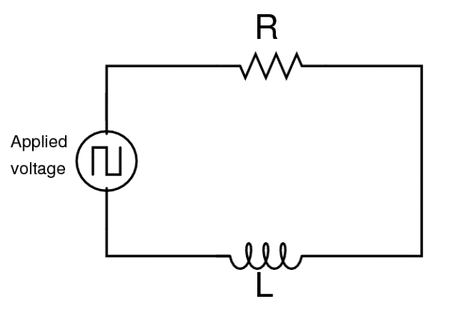

**Experimental data:**

**a.**

|  |  |
| --- | --- |
| **Item** | **Value** |
| Inductor resistance | 6.1 |
| Resistor resistance | 15.4 |
| Total resistance | 21.5 |
| Time at peak voltage | 0.0212 |
| Time at half-maximum voltage | 0.0221 |
| Time to reach half-maximum | 0.0009 |
|  | 0.0013 |
|  | 0.001302 |

**b.**

|  |  |
| --- | --- |
| **Item** | **Value** |
| Inductor resistance | 6.1 |
| Resistor resistance | 6 |
| Total resistance | 12.1 |
| Time at peak voltage | 0.0412 |
| Time at half-maximum voltage | 0.0428 |
| Time to reach half-maximum | 0.0016 |
|  | 0.0023 |
|  | 0.0023 |

**Questions:**

1. How does the inductive time constant found in this experiment compare to the theoretical value given by ? (Remember that R is the total resistance of the circuit and therefore must include the resistance of the coil as well as the resistance of the resistor.)

For both experiments (a and b), the values of τ calculated from the two methods are very close:

For experiment a, τ is approximately 0.0013 s from the first method and 0.001302 s from the second method.

For experiment b, τ is approximately 0.0023 s from both methods.

This suggests that the experimental values of the inductive time constant are consistent with the theoretical prediction given by τ = L/R. This indicates that our experiment was conducted accurately and the results are reliable.

1. Does Kirchhoff’s Loop Rule hold at all times? Use the graphs to check it for at least three different times. Does the sum of the voltages across the resistor and the inductor equal the source voltage at any given time?

Yes, Kirchhoff's Loop Rule holds at all times. This rule states that the sum of the voltages around any closed loop in a circuit is zero. This can be expressed mathematically as: ΣV = 0

In all three cases, the sum of the voltages is equal to the source voltage, V_s. This shows that Kirchhoff's Loop Rule holds for the RL circuit at all times.

The reason why Kirchhoff's Loop Rule holds is because energy is conserved. The energy stored in the inductor is equal to the work done by the source in moving the charge carriers around the loop. This work is equal to the product of the source voltage and the current through the loop. Therefore, the sum of the voltages around the loop must be zero, or the energy would not be conserved.

1. How does the value of the resistor effect to the inductive time constant τ?

We can see that the time constant is inversely proportional to the resistance. This means that if the resistance increases, the time constant decreases, and vice versa.

In other words, for a fixed value of inductance, increasing the resistance value makes the transient time and therefore the time constant of the circuit shorter. This is because a higher resistance will cause the current to reach its maximum value more quickly, reducing the time constant.

So, the value of the resistor has a significant effect on the inductive time constant. It’s one of the key parameters that determine how quickly the circuit responds to changes

**Extension**

|  |  |
| --- | --- |
| **Item** | **Value** |
| Time at peak voltage | 0.0412 |
| Time at half-maximum voltage | 0.6785 |
| Time to reach half-maximum | 0.6373 |
|  | 0.9194 |

From the table above, calculate the new value of inductance. How does the iron core affect to the value of the inductance?